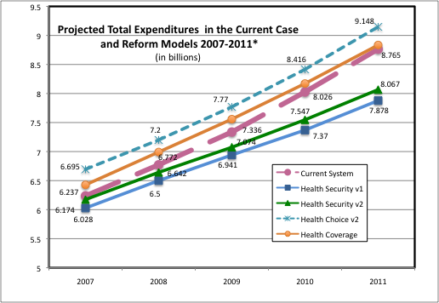*Study excludes over-65 and institutional populations. Study also assumes everyone has insurance.
Source: Mathematica Policy Research, Inc., “Quantitative and Comparative Analysis of Reform Options for Extending Health Care Coverage in New Mexico,” Final Report, July 31, 2007, p. 65

